PROJECT IMPLEMENTATION
TITLE OF THE PROJECT: Basic Calculator Using GUI
PROJECT DOMAIN: Python Programming – GUI Application Development

INDEX

SNO. | CONTENT | PAGE NO.
1. | Source code | 2
2. | Input Screens | 8
3. | Output Screens | 8
4. | Test cases | 9

NAME: REGISTRATION NO:

- SOURCE CODE:
import tkinter as tk
import math
# Main window
root = tk.Tk()
root.title("Scientific Calculator")
root.geometry("500x650")
root.resizable(False, False)
# Display
display = tk.Entry(root, font=("Arial", 28), borderwidth=2, relief="ridge", justify="right")
display.grid(row=0, column=0, columnspan=8, ipadx=8, ipady=25, sticky="nsew")
# Configure rows & columns
for i in range(8):
root.columnconfigure(i, weight=1)
for i in range(6):
root.rowconfigure(i, weight=1)
# Function for button click
def on_click(btn_text):
if btn_text == "=":
try:
expr = display.get()
expr = expr.replace("×", "").replace("÷", "/").replace("−", "-").replace("xʸ", "*")
expr = expr.replace("π", str(math.pi)).replace("e", str(math.e))
expr = expr.replace("ln", "math.log").replace("log", "math.log10")
expr = expr.replace("√", "math.sqrt")
expr = expr.replace("sin", "math.sin").replace("cos", "math.cos").replace("tan", "math.tan")
expr = expr.replace("EXP", "10*")
if "x!" in expr:
n = int(expr.split("x!")[0])
expr = str(math.factorial(n))
result = eval(expr)
display.delete(0, tk.END)
display.insert(tk.END, str(result))
except Exception:
display.delete(0, tk.END)
display.insert(tk.END, "Error")
elif btn_text == "CE":
display.delete(0, tk.END)
else:
display.insert(tk.END, btn_text)
# Button layout
buttons = [
["Rad", "Deg", "x!", "(", ")", "%", "CE"],
["Inv", "sin", "ln", "7", "8", "9", "÷"],
["π", "cos", "log", "4", "5", "6", "×"],
["e", "tan", "√", "1", "2", "3", "−"],
["Ans", "EXP", "xʸ", "0", ".", "=", "+"]
]
# Create buttons
for r, row in enumerate(buttons, 1):
c = 0
while c < len(row):
text = row[c]
if text == "=": # Wide =
btn = tk.Button(root, text=text, font=("Arial", 16, "bold"), bg="#2f6df2", fg="white",
command=lambda t=text: on_click(t))
btn.grid(row=r, column=c, columnspan=2, sticky="nsew", ipadx=10, ipady=20)
c += 2
else:
btn = tk.Button(root, text=text, font=("Arial", 16), bg="#e8ebf7",
command=lambda t=text: on_click(t))
btn.grid(row=r, column=c, sticky="nsew", ipadx=10, ipady=20)
c += 1
root.mainloop()
INPUT:
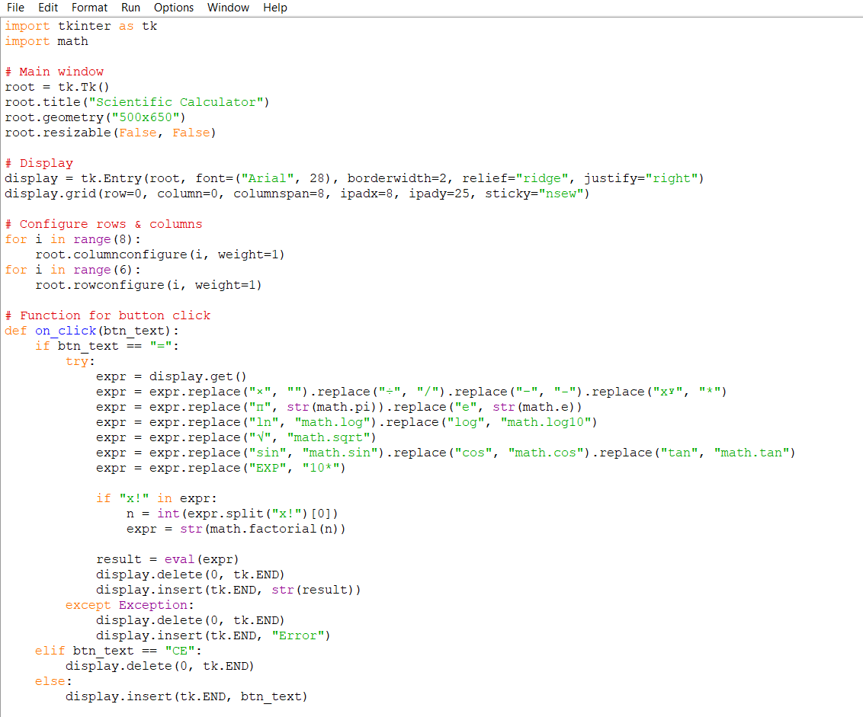
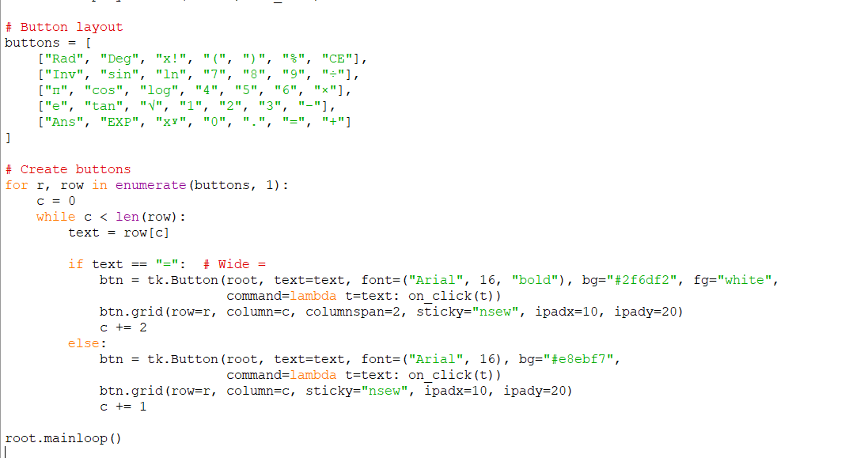

OUTPUT:
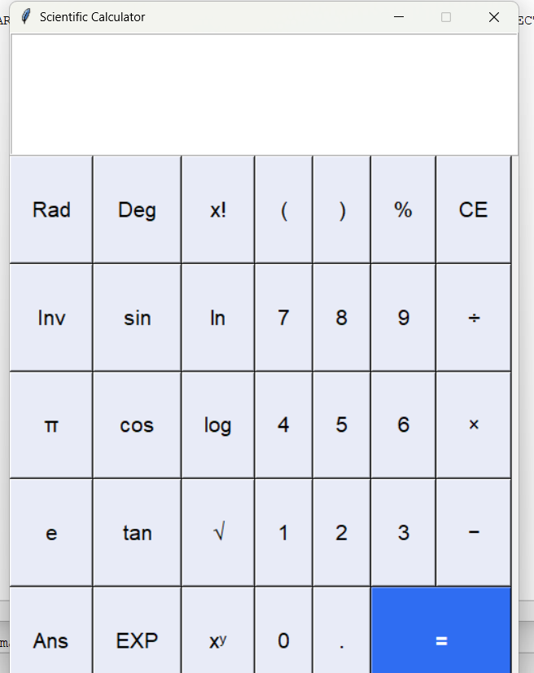

- TEST CASES:

